(Approx. 699 words)

Microsoft Office Apps for Your Apple or Android Devices
Nancy DeMarte, 1st Vice President, Sarasota Technology User Group, FL
August 2015 issue, Sarasota Technology Monitor
www.thestug.org / ndemarte (at) Verizon.net

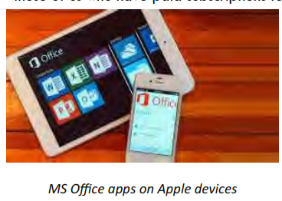
Microsoft Office is hugely successful in the Office suite market. Now they are giving free access to the most popular of these applications - Word, Excel, PowerPoint, Outlook, and OneNote – to anyone with an Apple or Android mobile device. It is true that those of us who have paid subscriptions to Office 365 get more features in our versions of these apps, but everyone else can get MS Oﬃce apps on Apple devices. The Office apps include the most popular and useful features in this powerful suite. The limited version of Word, for example, may not allow a user to put shadows behind a photo or add section breaks. But it does include a large collection of fonts and styles, margin settings, the ability to insert photos, tables, and headers and footers, plus many other tools needed to create a quality document.

Anyone who is willing to sign up for a free Microsoft account can download the mobile apps free to his or her tablet or smartphone from the iTunes store (Apple) or Google Play store (Android). Requirements for Apple devices are iPad with iOS 7 or later and iPhone 5, 6 or 6 plus. For Android devices, the requirements for tablets and phones are kitkat4.4 or later and an ARM-based or Intel 86 processor and a 7’-10.1’ screen on a tablet, according the Microsoft website.

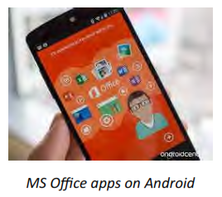
All the apps come with a large number of templates for easy design looks. Excel has over 25 templates. PowerPoint includes more slide types than the full-featured version. All the apps are formatted for touch by streamlining the command ribbon and putting more space between each icon. They also work well with a keyboard.

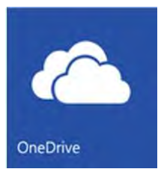
The perfect accompaniment to the Office apps is the OneDrive mobile app. This Microsoft cloud storage app includes a generous amount of free storage to non-Office 365 users: 15GB, plus 3 GB more if you enable automatic photo uploads and 5GB more if you refer five people to OneDrive. That is more free storage than iCloud, Google Drive or Dropbox. (Office 365 subscribers get 1TB (1000 GB) of free storage, offering an incentive for joining the paid Office crowd.) Not only can you save photos, documents and other files there, but they can be accessed from your PC, tablet or phone, as long as you have the OneDrive app.

The newest OneDrive version, 5.4.2, works more smoothly than earlier versions. After a small learning curve, I could use all the features of the app – add items, organize my folders, and share photos and other files – with none of the glitches I had experienced with earlier versions. There are only a few menu options to learn, and these give the user a lot of flexibility.

Documents, presentations, or spreadsheets created in the Word, PowerPoint, or Excel app can be saved to OneDrive, where they can be organized and shared with others via email or by sending a hyperlink. Photos taken on a device can be set to upload automatically. They become available on your other devices where you have installed OneDrive. The major restriction for non-Office 365 subscribers is that files created in the
apps cannot be edited collaboratively.

Note: The “modern” format style used in the OneDrive app is so minimalistic that the tool icons can be easy to miss. For instance, when viewing a photo in OneDrive, you may not see any commands at all. To view the toolbar, tap the bottom of the screen. Tap the three dots on the bottom right to see the main functions, such as “Add Items” and “Sort by.” Other icons include tools for Sharing, Trash, and Organizing. The iPad/Phone icon designs are consistent with iOS icons. The Android icons are much like the ones used by Google.

People today are on the go. If I can take Microsoft Office with me on my iPad or iPhone, and have access to all the files I have stored on OneDrive, I won’t get bored on that next trip or burdened down with my laptop.

